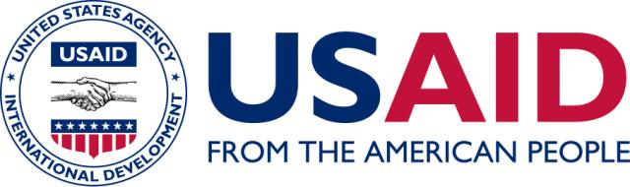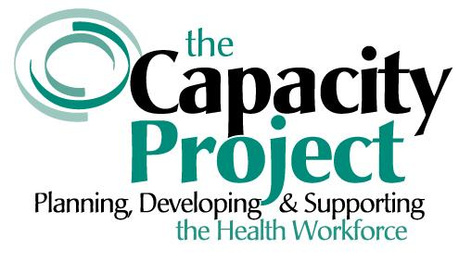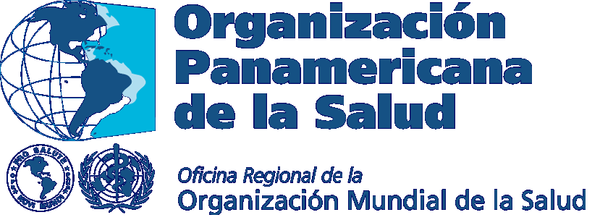

WORKSHOP AGENDA
USING THE HRH ACTION FRAMEWORK
TO ADDRESS HRH CHALLENGES
SEPTEMBER 16 – 18, 2008
LIMA, PERU

PURPOSE
The Human Resources for Health Action Framework (HAF) has been developed to assist governments and health managers in developing and implementing strategies for achieving an effective and sustainable health workforce. By using a comprehensive approach, the Framework will help address issues such as staff shortages, uneven distribution of staff, gaps in skills and competencies, low retention and poor motivation. As the countries of the Latin American and Caribbean Region launch their 10-year plans to achieve the Regional Goals for Human Resources for Health, the HAF provides useful tools, resources, methodologies, and examples. The purpose of this 3-day workshop is to introduce this framework and build skills for its use.

OBJECTIVES
- Introduce the HRH Action Framework (HAF) to HRH stakeholders from the Andean Region through explanation, country examples and open discussion
- Enable participants to become familiar with using the HAF as a tool for addressing their HRH challenges
- Develop specific country plans for using the HAF to build and carry out their HRH strategies to reach their 10-year HRH Goals

Day One

9:00 Introductory session
- Welcome
- Introductions
- Background, objectives, and agenda for the meeting
- Presentation and discussion on Regional Goals for Human Resources for Health 2007 – 2015

10:30 Morning break

10:45 Setting the context
- The HRH crisis at the country level: What do we see – progress, challenges, obstacles? What are future areas of interest? (Participants working in country teams describe most important HRH issues in their countries at this point in time.)
- General discussion on major challenges to meeting the 10 year HRH Goals

12:00 HRH Action Framework – Presentation and discussion
- Action fields – HR management systems, leadership, partnership, finance, education and policy
- Action cycle – Situation analysis, planning, implementation, and monitoring and evaluation
- Navigating the website to access tools and resources

12:30 Lunch

2:00 Continue with above presentation and discussion

2:30 Critical Success Factors – those factors that have proven to be of vital importance in planning and implementing improved HR approaches and practices
- Process-Related Factors
- Content- Related Factors
- Country team analysis and discussion

3:45 Mid afternoon break

4:00 Action Field Topic working groups for Policy, Finance, Education, Partnership, Leadership, and HR Management Systems
- Potential areas for intervention
- Possible indicators in light of the 20 HRH Goals
- Useful tools and resources

5:30/6:00 Closure for the day

Day 2

9:00 Action Field Topic Work groups report out

10:45 Mid morning break

11:00 Country examples of how HRH Action Framework is being used to support improved HRH planning and implementation

12:30 Lunch

2:00 Ideas for using the HRH Action Framework to address critical HRH challenges at the country level

2:45 Country teams working on their HRH plans and strategies, using the
HRH Action Framework as appropriate
- Where are we currently in developing HRH plans/strategies
- What is our initial thinking about how we would begin to use the concepts and tools the HAF presents?
- What critical success factors should we focus on?

3:45 Mid afternoon break

4:00 Country teams share thinking on above points and discuss following points:
- Who should be our key stakeholders?
- What are the best ways to involve them?

5:30 Closure for the day

Day 3

9:00 Using the Action Cycle – Situational Analysis; Planning; Implementation; Monitoring and Evaluation

10:30 Morning break

10:45 Country teams continue to work on their HRH plans and strategies, using the HRH Action Framework as appropriate.
- Which of the Action Fields are focus points for us over the next 12 months or so? Over the next 2 years?
- What are our plans for carrying these Action Fields forward?

11:45 Country teams share plans, seek helpful feedback and identify any areas where collaboration or continued information/dialogue about progress at the country level could be useful

12:30 Lunch

2:00 Finish sharing country plans and wrap up discussions

3:00 Next steps – how PAHO and the Capacity Project can be supportive

4:00 Workshop Closure

